Alternate Entry Form

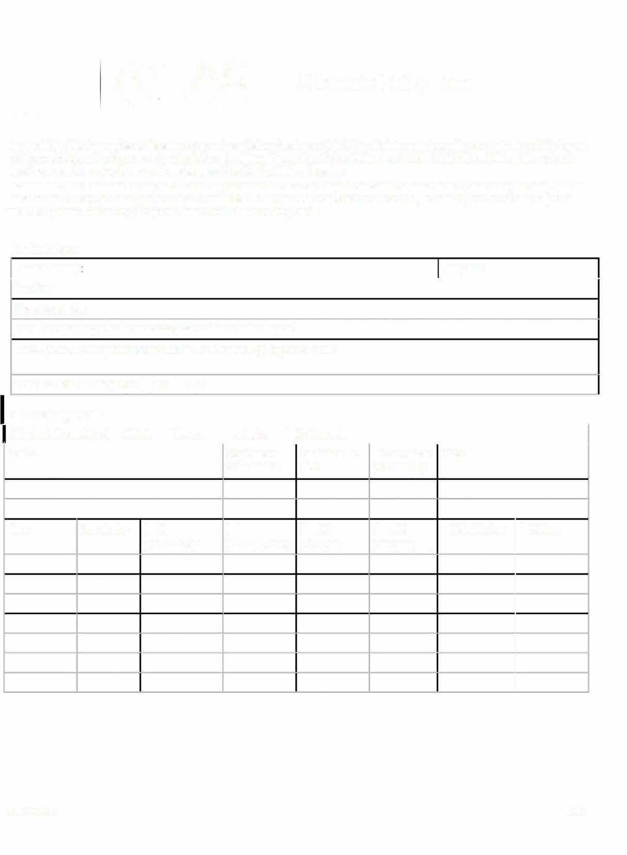

**Applicability.** This form applies to the entry of a permit-required confined space (PRCS) in which **the only hazard is atmospheric** and this hazard can be controlled and the space maintained safe for entry with continuous forced air ventilation (per 29 CFR 1910.146, c, 5). If conditions do not meet these requirements or for more information, see Atlas Confined Entry Procedure

**Instructions.** This form must be completed before anyone enters the space and kept at or near the entrance to the space during the entry. All form must be sent to the project manager once work is completed. To ensure entry conditions are acceptable, this form is good for one day only. For work lasting more than one day, a separate form is needed for each day's work.

**Confined Space**

|  |
| --- |
| Reason for entry Entry date: |
| Location:  Space description: |
| List all known atmospheric hazards associated with the confined space:  List all potential atmospheric hazards that will be introduced by the planned work: |
| Forced air ventilation required? DYes D No |

**Air Monitoring Results**

|  |  |  |  |  |  |  |  |
| --- | --- | --- | --- | --- | --- | --- | --- |
| Attendant will sample air D Initially D Every minutes D Continuously | | | | | | | |
| Device | | | Sequence or serial number | Calibration due date | Pre-use check Notes performed by | | |
|  | | | □  (LEULFL <10%) | □ co  (<25 ppm) |  |  |  |
| Time | Sampled by | DO2  (19.5-23.5%) | H2S  (<10 ppm) | Stratification | Other: |
|  |  | |  | |  | |  |
|  |  | |  | |  | |  |
|  |  | |  | |  | |  |
|  |  | |  | |  | |  |
|  |  | |  | |  | |  |

January 2017 **I of2**

**Personnel Entry and Exit Record** *(to be completed as needed before and during work)*

|  |  |  |  |  |  |  |
| --- | --- | --- | --- | --- | --- | --- |
| Attendant name: | Entrant name: | Entrant name: | Entrant name: | Entrant name: | Entrant name: | Entrant name: |
| Time in |  |  |  |  |  |  |
| Time out |  |  |  |  |  |  |
| Time in |  |  |  |  |  |  |
| Time out |  |  |  |  |  |  |
| Time in |  |  |  |  |  |  |
| Time out |  |  |  |  |  |  |
| Time in |  |  |  |  |  |  |
| Time out |  |  |  |  |  |  |
| Time in |  |  |  |  |  |  |
| Time out |  |  |  |  |  |  |
| Time in |  |  |  |  |  |  |
| Time out |  |  |  |  |  |  |
| Time in |  |  |  |  |  |  |
| Time out |  |  |  |  |  |  |
| Time in |  |  |  |  |  |  |
| Time out |  |  |  |  |  |  |
| Time in |  |  |  |  |  |  |
| Time out |  |  |  |  |  |  |
| Time in |  |  |  |  |  |  |
| Time out |  |  |  |  |  |  |
| Notes: | | | | | | |

**Confirmation** *(must be signed by the confined space entry supervisor before work begins)*

|  |  |
| --- | --- |
| I confirm that the named PRCS and the planned work qualify for alternate entry. Name: | |
| Signature: | Date: |

January 2017 2 of 2